WellPlanTM Report

Нефть Шельф
Well Name: PH-4
Wellbore:
Design:
Case: PH-4

Date: April 7, 2026 at 6:30 PM

Created By: edm

General Information
  - General Case Information
Company | Нефть Шельф
Project | Нагнетательная скважина | Site | МЛСП
Well | PH-4 | Wellbore
Design |  | Case | PH-4
Hole MD | 1470,00 m | Hole TVD | 1258,52 m
Air Gap | 35,00 m | Water Depth | 50,00 m
Reference Point | Datum #1 @ m | Well Type | Platform
  - Active Fluid

Fluid Data
Fluid | Mud #1 | Type | Mud
Mud Base Type | Brine | Base Fluid | Brine
Rheology Model | Newtonian | Foamed

Compressibility Data
Oil (Vol)/Water (Vol) | 80,00 %/20,00 % | Reference Temperature | 21,111
Salt Content (wt) | 10,00 | Average Solid Gravity | 2,000

Rheology Data
Temperature  (°C) | Pressure  (kPa) | Base Density  (kg/m³) | Ref Fluid Properties | PV (Mulnf)  (mPa*s) | Fann Data
 |  |  |  |  | Speed  (rpm) | Dial  (°)
21,111 | 101,35 | 812 | Yes | 24
  - Hole Section
Section  Type | Section Depth  (m) | Section Length  (m) | Shoe Depth  (m) | ID  (mm) | Drift  (mm) | Eff. Hole Diameter  (mm) | Coefficient  of  Friction | Linear Capacity  (L/m) | Volume  Excess  (%)
Casing | 1470 | 1470 | 1470 | 220,5 | 219,08 | 311,15 | 0,23 | 38,19
  - String Details
Type | Length  (m) | Depth  (m) | Body |  | Stabilizer / Tool Joint |  |  |  | Weight | Material | Grade | Class
 |  |  | OD  (mm) | ID  (mm) | Avg Joint Length  (m) | Length  (m) | OD  (mm) | ID  (mm)
Tubing | 1458 | 1458 | 139,7 | 124,26 |  |  |  |  | 25,3 | CS_API 5CT | L-80
Packer | 2 | 1460 | 214 | 100,5 | 2 |  |  |  | 50 | CS_API 5CT | 4145H MOD

Grade in Use
Grade | Minimum Yield Stress (kPa)
4145H MOD | 758 423
L-80 | 551 581
  - Wellpath - Calculation Method: Minimum Curvature
MD  (m) | INC  (°) | AZ  (°) | TVD  (m) | DLS  (°/30m) | AbsTort  (°/30m) | RelTort  (°/30m) | VSect  (m) | NS  (m) | EW  (m) | Build  (°/30m) | Walk  (°/30m)
0,00 | 0,00 | 0,00 | 0,00 | 0,000 | 0,000 | 0,000 | 0,00 | 0,00 | 0,00 | 0,000 | 0,000
10,00 | 0,15 | 227,64 | 10,00 | 0,450 | 0,450 | 0,000 | -0,01 | -0,01 | -0,01 | 0,450 | 0,000
20,00 | 0,18 | 213,73 | 20,00 | 0,150 | 0,300 | 0,000 | -0,03 | -0,03 | -0,03 | 0,090 | -41,730
30,00 | 0,20 | 182,38 | 30,00 | 0,313 | 0,304 | 0,000 | -0,06 | -0,06 | -0,04 | 0,060 | -94,050
40,00 | 0,13 | 192,60 | 40,00 | 0,227 | 0,285 | 0,000 | -0,09 | -0,09 | -0,04 | -0,210 | 30,660
50,00 | 0,13 | 179,67 | 50,00 | 0,088 | 0,246 | 0,000 | -0,11 | -0,11 | -0,04 | 0,000 | -38,790
60,00 | 0,28 | 160,29 | 60,00 | 0,490 | 0,286 | 0,000 | -0,15 | -0,15 | -0,03 | 0,450 | -58,140
70,00 | 0,18 | 139,65 | 70,00 | 0,385 | 0,300 | 0,000 | -0,18 | -0,18 | -0,02 | -0,300 | -61,920
80,00 | 0,34 | 150,37 | 80,00 | 0,500 | 0,325 | 0,000 | -0,22 | -0,22 | 0,01 | 0,480 | 32,160
90,00 | 0,28 | 162,50 | 90,00 | 0,266 | 0,319 | 0,000 | -0,27 | -0,27 | 0,03 | -0,180 | 36,390
100,00 | 0,43 | 157,40 | 100,00 | 0,459 | 0,333 | 0,000 | -0,33 | -0,33 | 0,05 | 0,450 | -15,300
110,00 | 0,39 | 153,52 | 110,00 | 0,146 | 0,316 | 0,000 | -0,39 | -0,39 | 0,08 | -0,120 | -11,640
120,00 | 0,55 | 131,10 | 120,00 | 0,723 | 0,350 | 0,000 | -0,45 | -0,45 | 0,13 | 0,480 | -67,260
130,00 | 0,55 | 152,12 | 130,00 | 0,602 | 0,369 | 0,000 | -0,53 | -0,53 | 0,19 | 0,000 | 63,060
140,00 | 0,34 | 183,56 | 140,00 | 0,944 | 0,410 | 0,000 | -0,60 | -0,60 | 0,21 | -0,630 | 94,320
150,00 | 0,19 | 211,76 | 150,00 | 0,584 | 0,422 | 0,000 | -0,64 | -0,64 | 0,20 | -0,450 | 84,600
160,00 | 0,39 | 357,74 | 160,00 | 1,673 | 0,500 | 0,000 | -0,62 | -0,62 | 0,19 | 0,600 | 437,940
170,00 | 1,38 | 6,47 | 170,00 | 2,989 | 0,646 | 0,000 | -0,47 | -0,47 | 0,20 | 2,970 | 26,190
180,00 | 2,27 | 354,35 | 179,99 | 2,896 | 0,771 | 0,000 | -0,15 | -0,15 | 0,20 | 2,670 | -36,360
190,00 | 2,93 | 350,08 | 189,98 | 2,062 | 0,839 | 0,000 | 0,30 | 0,30 | 0,13 | 1,980 | -12,810
200,00 | 3,87 | 348,23 | 199,96 | 2,839 | 0,939 | 0,000 | 0,88 | 0,88 | 0,02 | 2,820 | -5,550
210,00 | 4,90 | 339,06 | 209,93 | 3,729 | 1,072 | 0,000 | 1,61 | 1,61 | -0,20 | 3,090 | -27,510
220,00 | 5,77 | 337,28 | 219,89 | 2,656 | 1,144 | 0,000 | 2,47 | 2,47 | -0,55 | 2,610 | -5,340
230,00 | 6,43 | 334,57 | 229,83 | 2,160 | 1,188 | 0,000 | 3,44 | 3,44 | -0,98 | 1,980 | -8,130
240,00 | 7,29 | 327,91 | 239,76 | 3,510 | 1,285 | 0,000 | 4,48 | 4,48 | -1,56 | 2,580 | -19,980
250,00 | 7,87 | 323,92 | 249,67 | 2,349 | 1,328 | 0,000 | 5,57 | 5,57 | -2,30 | 1,740 | -11,970
260,00 | 8,77 | 321,41 | 259,57 | 2,911 | 1,388 | 0,000 | 6,72 | 6,72 | -3,18 | 2,700 | -7,530
270,00 | 9,41 | 315,35 | 269,44 | 3,452 | 1,465 | 0,000 | 7,90 | 7,90 | -4,23 | 1,920 | -18,180
280,00 | 10,15 | 309,91 | 279,30 | 3,549 | 1,539 | 0,000 | 9,05 | 9,05 | -5,48 | 2,220 | -16,320
290,00 | 10,48 | 307,27 | 289,14 | 1,729 | 1,546 | 0,000 | 10,16 | 10,16 | -6,88 | 0,990 | -7,920
300,00 | 10,84 | 304,64 | 298,96 | 1,815 | 1,555 | 0,000 | 11,25 | 11,25 | -8,38 | 1,080 | -7,890
310,00 | 11,25 | 309,25 | 308,78 | 2,920 | 1,599 | 0,000 | 12,40 | 12,40 | -9,90 | 1,230 | 13,830
320,00 | 11,48 | 310,10 | 318,58 | 0,854 | 1,576 | 0,000 | 13,66 | 13,66 | -11,42 | 0,690 | 2,550
330,00 | 11,49 | 311,08 | 328,38 | 0,586 | 1,546 | 0,000 | 14,95 | 14,95 | -12,93 | 0,030 | 2,940
340,00 | 11,58 | 308,94 | 338,18 | 1,312 | 1,539 | 0,000 | 16,24 | 16,24 | -14,46 | 0,270 | -6,420
350,00 | 12,05 | 305,72 | 347,97 | 2,429 | 1,564 | 0,000 | 17,48 | 17,48 | -16,09 | 1,410 | -9,660
360,00 | 12,61 | 305,61 | 357,74 | 1,681 | 1,567 | 0,000 | 18,72 | 18,72 | -17,83 | 1,680 | -0,330
370,00 | 12,72 | 306,76 | 367,50 | 0,825 | 1,547 | 0,000 | 20,02 | 20,02 | -19,60 | 0,330 | 3,450
380,00 | 13,33 | 310,81 | 377,24 | 3,292 | 1,593 | 0,000 | 21,43 | 21,43 | -21,35 | 1,830 | 12,150
390,00 | 13,54 | 313,31 | 386,97 | 1,853 | 1,600 | 0,000 | 22,99 | 22,99 | -23,08 | 0,630 | 7,500
400,00 | 13,21 | 318,42 | 396,69 | 3,680 | 1,652 | 0,000 | 24,65 | 24,65 | -24,69 | -0,990 | 15,330
410,00 | 13,00 | 319,42 | 406,43 | 0,927 | 1,634 | 0,000 | 26,35 | 26,35 | -26,18 | -0,630 | 3,000
420,00 | 12,83 | 322,56 | 416,18 | 2,166 | 1,647 | 0,000 | 28,09 | 28,09 | -27,58 | -0,510 | 9,420
430,00 | 12,80 | 325,25 | 425,93 | 1,792 | 1,650 | 0,000 | 29,88 | 29,88 | -28,89 | -0,090 | 8,070
440,00 | 12,64 | 327,03 | 435,69 | 1,270 | 1,642 | 0,000 | 31,71 | 31,71 | -30,12 | -0,480 | 5,340
450,00 | 12,71 | 326,75 | 445,44 | 0,279 | 1,611 | 0,000 | 33,55 | 33,55 | -31,31 | 0,210 | -0,840
460,00 | 12,67 | 329,38 | 455,20 | 1,737 | 1,614 | 0,000 | 35,41 | 35,41 | -32,48 | -0,120 | 7,890
470,00 | 13,26 | 326,66 | 464,94 | 2,546 | 1,634 | 0,000 | 37,31 | 37,31 | -33,67 | 1,770 | -8,160
480,00 | 13,88 | 324,10 | 474,66 | 2,589 | 1,654 | 0,000 | 39,24 | 39,24 | -35,00 | 1,860 | -7,680
490,00 | 14,67 | 322,49 | 484,36 | 2,652 | 1,674 | 0,000 | 41,22 | 41,22 | -36,47 | 2,370 | -4,830
500,00 | 15,65 | 321,94 | 494,01 | 2,971 | 1,700 | 0,000 | 43,29 | 43,29 | -38,08 | 2,940 | -1,650
510,00 | 16,62 | 321,44 | 503,61 | 2,940 | 1,724 | 0,000 | 45,47 | 45,47 | -39,80 | 2,910 | -1,500
520,00 | 17,52 | 321,34 | 513,17 | 2,701 | 1,743 | 0,000 | 47,76 | 47,76 | -41,63 | 2,700 | -0,300
530,00 | 18,36 | 321,45 | 522,69 | 2,522 | 1,758 | 0,000 | 50,17 | 50,17 | -43,55 | 2,520 | 0,330
540,00 | 19,20 | 321,55 | 532,15 | 2,522 | 1,772 | 0,000 | 52,69 | 52,69 | -45,56 | 2,520 | 0,300
550,00 | 19,33 | 322,48 | 541,59 | 1,000 | 1,758 | 0,000 | 55,29 | 55,29 | -47,59 | 0,390 | 2,790
560,00 | 19,42 | 323,46 | 551,03 | 1,012 | 1,745 | 0,000 | 57,94 | 57,94 | -49,58 | 0,270 | 2,940
562,00 | 19,43 | 323,65 | 552,91 | 0,960 | 1,742 | 0,000 | 58,47 | 58,47 | -49,98 | 0,150 | 2,850
570,00 | 19,50 | 324,43 | 560,46 | 1,009 | 1,732 | 0,000 | 60,63 | 60,63 | -51,55 | 0,263 | 2,925
580,00 | 20,10 | 324,30 | 569,87 | 1,805 | 1,733 | 0,000 | 63,38 | 63,38 | -53,52 | 1,800 | -0,390
590,00 | 19,38 | 325,75 | 579,28 | 2,612 | 1,748 | 0,000 | 66,15 | 66,15 | -55,46 | -2,160 | 4,350
600,00 | 18,67 | 327,31 | 588,73 | 2,620 | 1,762 | 0,000 | 68,87 | 68,87 | -57,25 | -2,130 | 4,680
610,00 | 18,21 | 328,84 | 598,22 | 2,003 | 1,766 | 0,000 | 71,55 | 71,55 | -58,93 | -1,380 | 4,590
620,00 | 18,35 | 330,01 | 607,71 | 1,178 | 1,757 | 0,000 | 74,25 | 74,25 | -60,52 | 0,420 | 3,510
630,00 | 18,81 | 330,80 | 617,19 | 1,573 | 1,754 | 0,000 | 77,02 | 77,02 | -62,10 | 1,380 | 2,370
640,00 | 19,52 | 331,27 | 626,64 | 2,180 | 1,761 | 0,000 | 79,89 | 79,89 | -63,68 | 2,130 | 1,410
650,00 | 20,23 | 331,70 | 636,04 | 2,175 | 1,767 | 0,000 | 82,88 | 82,88 | -65,31 | 2,130 | 1,290
660,00 | 20,78 | 331,93 | 645,41 | 1,668 | 1,765 | 0,000 | 85,97 | 85,97 | -66,96 | 1,650 | 0,690
670,00 | 21,25 | 332,07 | 654,74 | 1,418 | 1,760 | 0,000 | 89,14 | 89,14 | -68,65 | 1,410 | 0,420
680,00 | 21,73 | 332,20 | 664,05 | 1,447 | 1,756 | 0,000 | 92,37 | 92,37 | -70,36 | 1,440 | 0,390
690,00 | 22,21 | 332,03 | 673,32 | 1,453 | 1,751 | 0,000 | 95,68 | 95,68 | -72,11 | 1,440 | -0,510
700,00 | 22,69 | 331,83 | 682,56 | 1,458 | 1,747 | 0,000 | 99,05 | 99,05 | -73,90 | 1,440 | -0,600
710,00 | 23,18 | 331,62 | 691,77 | 1,490 | 1,743 | 0,000 | 102,48 | 102,48 | -75,75 | 1,470 | -0,630
720,00 | 24,16 | 330,57 | 700,93 | 3,200 | 1,764 | 0,000 | 106,00 | 106,00 | -77,69 | 2,940 | -3,150
730,00 | 25,13 | 329,59 | 710,02 | 3,158 | 1,783 | 0,000 | 109,61 | 109,61 | -79,77 | 2,910 | -2,940
740,00 | 26,08 | 328,73 | 719,04 | 3,060 | 1,800 | 0,000 | 113,32 | 113,32 | -81,99 | 2,850 | -2,580
750,00 | 26,80 | 328,15 | 727,99 | 2,295 | 1,807 | 0,000 | 117,11 | 117,11 | -84,32 | 2,160 | -1,740
760,00 | 27,52 | 327,60 | 736,89 | 2,288 | 1,813 | 0,000 | 120,98 | 120,98 | -86,75 | 2,160 | -1,650
770,00 | 28,30 | 326,99 | 745,73 | 2,492 | 1,822 | 0,000 | 124,92 | 124,92 | -89,28 | 2,340 | -1,830
780,00 | 29,23 | 326,24 | 754,49 | 2,993 | 1,837 | 0,000 | 128,94 | 128,94 | -91,92 | 2,790 | -2,250
790,00 | 30,16 | 325,52 | 763,18 | 2,988 | 1,851 | 0,000 | 133,04 | 133,04 | -94,70 | 2,790 | -2,160
800,00 | 31,11 | 325,06 | 771,78 | 2,935 | 1,865 | 0,000 | 137,23 | 137,23 | -97,60 | 2,850 | -1,380
810,00 | 32,09 | 324,86 | 780,30 | 2,957 | 1,878 | 0,000 | 141,52 | 141,52 | -100,61 | 2,940 | -0,600
820,00 | 33,07 | 324,68 | 788,73 | 2,954 | 1,892 | 0,000 | 145,91 | 145,91 | -103,72 | 2,940 | -0,540
830,00 | 33,91 | 324,24 | 797,07 | 2,623 | 1,900 | 0,000 | 150,40 | 150,40 | -106,93 | 2,520 | -1,320
840,00 | 34,68 | 323,66 | 805,33 | 2,509 | 1,908 | 0,000 | 154,96 | 154,96 | -110,24 | 2,310 | -1,740
850,00 | 35,44 | 323,10 | 813,51 | 2,476 | 1,914 | 0,000 | 159,57 | 159,57 | -113,67 | 2,280 | -1,680
860,00 | 36,26 | 322,41 | 821,62 | 2,742 | 1,924 | 0,000 | 164,23 | 164,23 | -117,21 | 2,460 | -2,070
870,00 | 37,09 | 321,71 | 829,64 | 2,788 | 1,934 | 0,000 | 168,94 | 168,94 | -120,89 | 2,490 | -2,100
880,00 | 37,93 | 321,04 | 837,57 | 2,801 | 1,944 | 0,000 | 173,70 | 173,70 | -124,69 | 2,520 | -2,010
890,00 | 38,47 | 320,81 | 845,43 | 1,675 | 1,941 | 0,000 | 178,50 | 178,50 | -128,59 | 1,620 | -0,690
900,00 | 38,99 | 320,62 | 853,23 | 1,600 | 1,937 | 0,000 | 183,34 | 183,34 | -132,55 | 1,560 | -0,570
910,00 | 39,45 | 320,39 | 860,98 | 1,447 | 1,932 | 0,000 | 188,22 | 188,22 | -136,57 | 1,380 | -0,690
920,00 | 39,45 | 319,91 | 868,70 | 0,915 | 1,920 | 0,000 | 193,10 | 193,10 | -140,64 | 0,000 | -1,440
930,00 | 39,46 | 319,42 | 876,42 | 0,935 | 1,910 | 0,000 | 197,94 | 197,94 | -144,75 | 0,030 | -1,470
940,00 | 39,45 | 318,98 | 884,14 | 0,839 | 1,898 | 0,000 | 202,75 | 202,75 | -148,91 | -0,030 | -1,320
950,00 | 39,40 | 318,65 | 891,87 | 0,646 | 1,885 | 0,000 | 207,53 | 207,53 | -153,09 | -0,150 | -0,990
960,00 | 39,36 | 318,32 | 899,60 | 0,639 | 1,872 | 0,000 | 212,28 | 212,28 | -157,29 | -0,120 | -0,990
970,00 | 39,32 | 318,35 | 907,33 | 0,133 | 1,854 | 0,000 | 217,02 | 217,02 | -161,51 | -0,120 | 0,090
980,00 | 39,31 | 318,88 | 915,07 | 1,008 | 1,846 | 0,000 | 221,77 | 221,77 | -165,70 | -0,030 | 1,590
990,00 | 39,29 | 319,41 | 922,81 | 1,009 | 1,837 | 0,000 | 226,56 | 226,56 | -169,84 | -0,060 | 1,590
1000,00 | 39,31 | 319,94 | 930,55 | 1,009 | 1,829 | 0,000 | 231,39 | 231,39 | -173,94 | 0,060 | 1,590
1010,00 | 39,36 | 320,48 | 938,28 | 1,038 | 1,821 | 0,000 | 236,26 | 236,26 | -177,99 | 0,150 | 1,620
1020,00 | 39,41 | 321,02 | 946,01 | 1,039 | 1,813 | 0,000 | 241,18 | 241,18 | -182,01 | 0,150 | 1,620
1030,00 | 39,40 | 320,92 | 953,74 | 0,193 | 1,798 | 0,000 | 246,11 | 246,11 | -186,01 | -0,030 | -0,300
1040,00 | 39,38 | 320,57 | 961,46 | 0,669 | 1,787 | 0,000 | 251,02 | 251,02 | -190,02 | -0,060 | -1,050
1050,00 | 39,35 | 320,21 | 969,20 | 0,691 | 1,776 | 0,000 | 255,91 | 255,91 | -194,07 | -0,090 | -1,080
1060,00 | 39,34 | 319,98 | 976,93 | 0,438 | 1,764 | 0,000 | 260,77 | 260,77 | -198,13 | -0,030 | -0,690
1070,00 | 39,32 | 319,76 | 984,66 | 0,423 | 1,751 | 0,000 | 265,62 | 265,62 | -202,22 | -0,060 | -0,660
1080,00 | 39,31 | 319,54 | 992,40 | 0,419 | 1,739 | 0,000 | 270,45 | 270,45 | -206,32 | -0,030 | -0,660
1090,00 | 39,31 | 319,59 | 1000,14 | 0,095 | 1,724 | 0,000 | 275,27 | 275,27 | -210,43 | 0,000 | 0,150
1100,00 | 39,32 | 319,63 | 1007,88 | 0,082 | 1,709 | 0,000 | 280,09 | 280,09 | -214,53 | 0,030 | 0,120
1110,00 | 39,33 | 319,64 | 1015,61 | 0,036 | 1,694 | 0,000 | 284,92 | 284,92 | -218,64 | 0,030 | 0,030
1120,00 | 39,40 | 319,45 | 1023,34 | 0,418 | 1,683 | 0,000 | 289,75 | 289,75 | -222,75 | 0,210 | -0,570
1130,00 | 39,47 | 319,26 | 1031,07 | 0,419 | 1,671 | 0,000 | 294,57 | 294,57 | -226,89 | 0,210 | -0,570
1140,00 | 39,55 | 319,14 | 1038,78 | 0,332 | 1,660 | 0,000 | 299,38 | 299,38 | -231,05 | 0,240 | -0,360
1150,00 | 39,64 | 319,15 | 1046,49 | 0,271 | 1,647 | 0,000 | 304,20 | 304,20 | -235,22 | 0,270 | 0,030
1160,00 | 39,73 | 319,16 | 1054,18 | 0,271 | 1,636 | 0,000 | 309,03 | 309,03 | -239,39 | 0,270 | 0,030
1170,00 | 39,81 | 319,45 | 1061,87 | 0,606 | 1,627 | 0,000 | 313,88 | 313,88 | -243,57 | 0,240 | 0,870
1180,00 | 39,86 | 320,02 | 1069,55 | 1,106 | 1,622 | 0,000 | 318,77 | 318,77 | -247,71 | 0,150 | 1,710
1190,00 | 39,92 | 320,59 | 1077,22 | 1,111 | 1,618 | 0,000 | 323,71 | 323,71 | -251,80 | 0,180 | 1,710
1200,00 | 39,92 | 320,78 | 1084,89 | 0,366 | 1,608 | 0,000 | 328,67 | 328,67 | -255,87 | 0,000 | 0,570
1210,00 | 39,88 | 320,74 | 1092,56 | 0,143 | 1,596 | 0,000 | 333,64 | 333,64 | -259,92 | -0,120 | -0,120
1220,00 | 39,84 | 320,71 | 1100,24 | 0,133 | 1,584 | 0,000 | 338,60 | 338,60 | -263,98 | -0,120 | -0,090
1230,00 | 40,01 | 320,70 | 1107,91 | 0,510 | 1,575 | 0,000 | 343,57 | 343,57 | -268,05 | 0,510 | -0,030
1240,00 | 40,23 | 320,70 | 1115,55 | 0,660 | 1,567 | 0,000 | 348,55 | 348,55 | -272,13 | 0,660 | 0,000
1250,00 | 40,46 | 320,70 | 1123,17 | 0,690 | 1,560 | 0,000 | 353,56 | 353,56 | -276,23 | 0,690 | 0,000
1260,00 | 41,19 | 321,10 | 1130,74 | 2,326 | 1,567 | 0,000 | 358,64 | 358,64 | -280,35 | 2,190 | 1,200
1270,00 | 41,95 | 321,52 | 1138,22 | 2,428 | 1,573 | 0,000 | 363,82 | 363,82 | -284,50 | 2,280 | 1,260
1280,00 | 42,70 | 321,90 | 1145,62 | 2,377 | 1,580 | 0,000 | 369,10 | 369,10 | -288,67 | 2,250 | 1,140
1290,00 | 43,45 | 322,13 | 1152,92 | 2,299 | 1,585 | 0,000 | 374,49 | 374,49 | -292,87 | 2,250 | 0,690
1300,00 | 44,19 | 322,36 | 1160,14 | 2,271 | 1,590 | 0,000 | 379,96 | 379,96 | -297,11 | 2,220 | 0,690
1310,00 | 45,02 | 322,46 | 1167,26 | 2,499 | 1,597 | 0,000 | 385,52 | 385,52 | -301,40 | 2,490 | 0,300
1320,00 | 46,10 | 322,24 | 1174,26 | 3,274 | 1,610 | 0,000 | 391,18 | 391,18 | -305,76 | 3,240 | -0,660
1330,00 | 47,18 | 322,02 | 1181,12 | 3,275 | 1,623 | 0,000 | 396,92 | 396,92 | -310,22 | 3,240 | -0,660
1340,00 | 48,20 | 321,80 | 1187,85 | 3,099 | 1,634 | 0,000 | 402,74 | 402,74 | -314,78 | 3,060 | -0,660
1350,00 | 49,13 | 321,58 | 1194,46 | 2,834 | 1,643 | 0,000 | 408,63 | 408,63 | -319,44 | 2,790 | -0,660
1360,00 | 50,06 | 321,36 | 1200,94 | 2,835 | 1,651 | 0,000 | 414,58 | 414,58 | -324,18 | 2,790 | -0,660
1370,00 | 50,93 | 321,22 | 1207,30 | 2,630 | 1,658 | 0,000 | 420,61 | 420,61 | -329,01 | 2,610 | -0,420
1380,00 | 51,75 | 321,14 | 1213,55 | 2,467 | 1,664 | 0,000 | 426,69 | 426,69 | -333,90 | 2,460 | -0,240
1390,00 | 52,57 | 321,06 | 1219,68 | 2,467 | 1,670 | 0,000 | 432,83 | 432,83 | -338,86 | 2,460 | -0,240
1400,00 | 53,63 | 320,70 | 1225,69 | 3,295 | 1,682 | 0,000 | 439,04 | 439,04 | -343,91 | 3,180 | -1,080
1410,00 | 54,79 | 320,24 | 1231,54 | 3,656 | 1,696 | 0,000 | 445,29 | 445,29 | -349,07 | 3,480 | -1,380
1420,00 | 55,95 | 319,80 | 1237,22 | 3,646 | 1,709 | 0,000 | 451,60 | 451,60 | -354,36 | 3,480 | -1,320
1430,00 | 56,90 | 319,87 | 1242,75 | 2,855 | 1,717 | 0,000 | 457,97 | 457,97 | -359,73 | 2,850 | 0,210
1440,00 | 57,83 | 320,02 | 1248,14 | 2,816 | 1,725 | 0,000 | 464,41 | 464,41 | -365,15 | 2,790 | 0,450
1450,00 | 58,75 | 320,17 | 1253,40 | 2,786 | 1,732 | 0,000 | 470,94 | 470,94 | -370,61 | 2,760 | 0,450
1460,00 | 59,68 | 320,23 | 1258,52 | 2,794 | 1,740 | 0,000 | 477,54 | 477,54 | -376,11 | 2,790 | 0,180
1470,00 | 60,60 | 320,29 | 1263,49 | 2,764 | 1,747 | 0,000 | 484,21 | 484,21 | -381,65 | 2,760 | 0,180
  - Pore Pressure
True Vertical Depth (TVD)  (m) | Pore Pressure  (kPa) | Equivalent Mud Weight (EMW)  (kg/m³)
85,00 | 859,00 | 1031
  - Fracture Gradient
True Vertical Depth (TVD)  (m) | Fracture Pressure  (kPa) | Equivalent Mud Weight (EMW)  (kg/m³)
85,00 | 0,00 | 0
  - Geothermal Gradient Data
Ambient Temperature | 10,000 °C | Mudline Temperature | 1,000 °C
Temperature @ Depth | 70,000 °C @ 1258,52 m | Gradient | 5,88 °C/100m

Schematics
Well: | IH-9 | Wellbore: |  | Case: | IH-9 | String Name: | Assembly
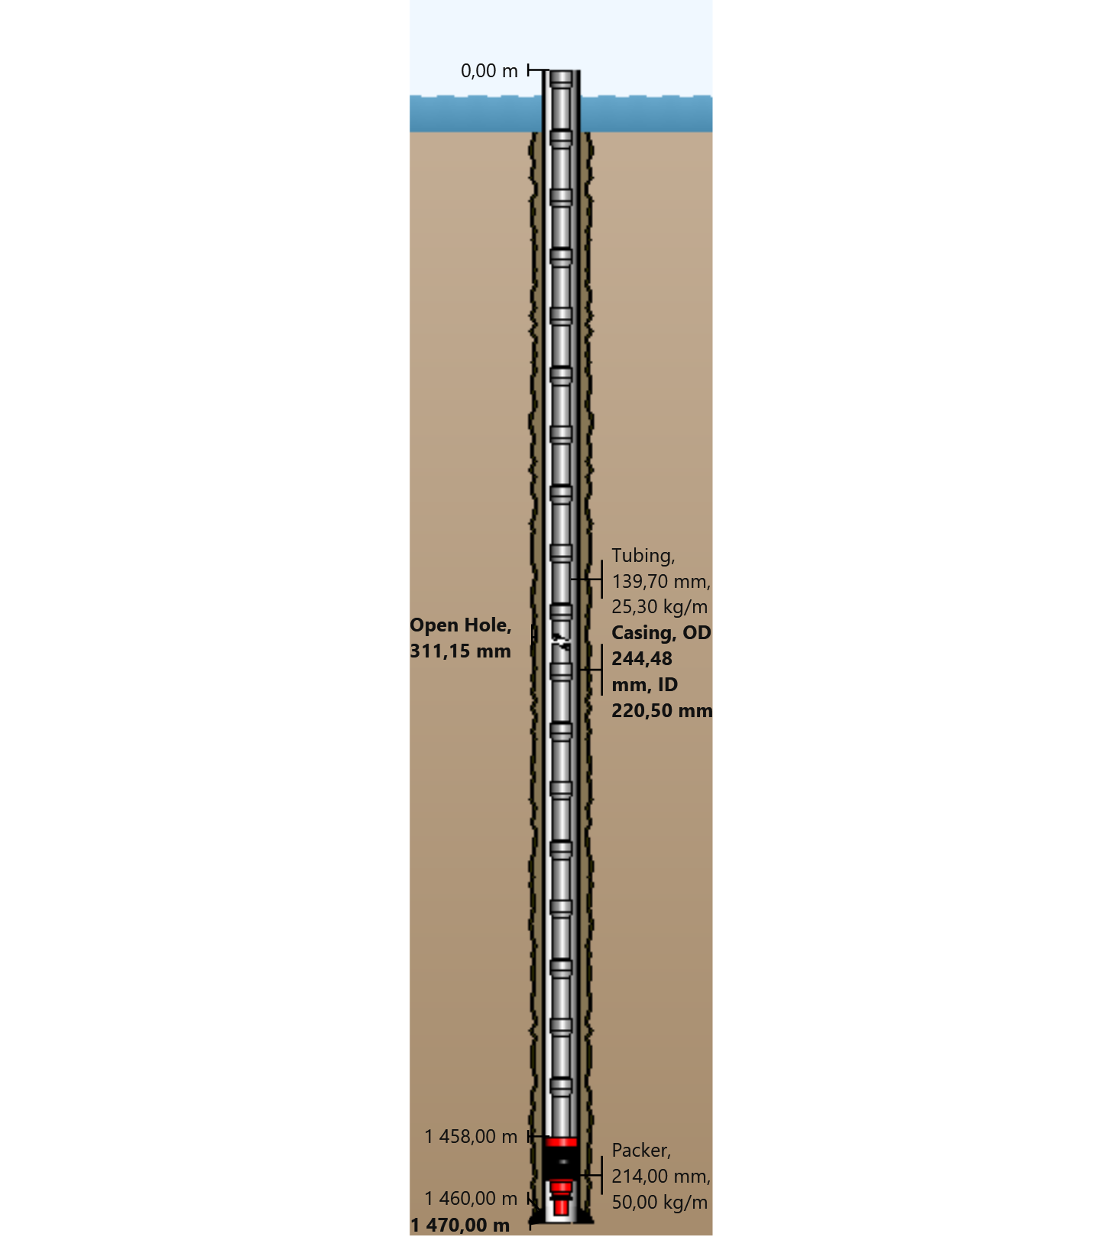

General Outputs Plots
  - Vertical Section
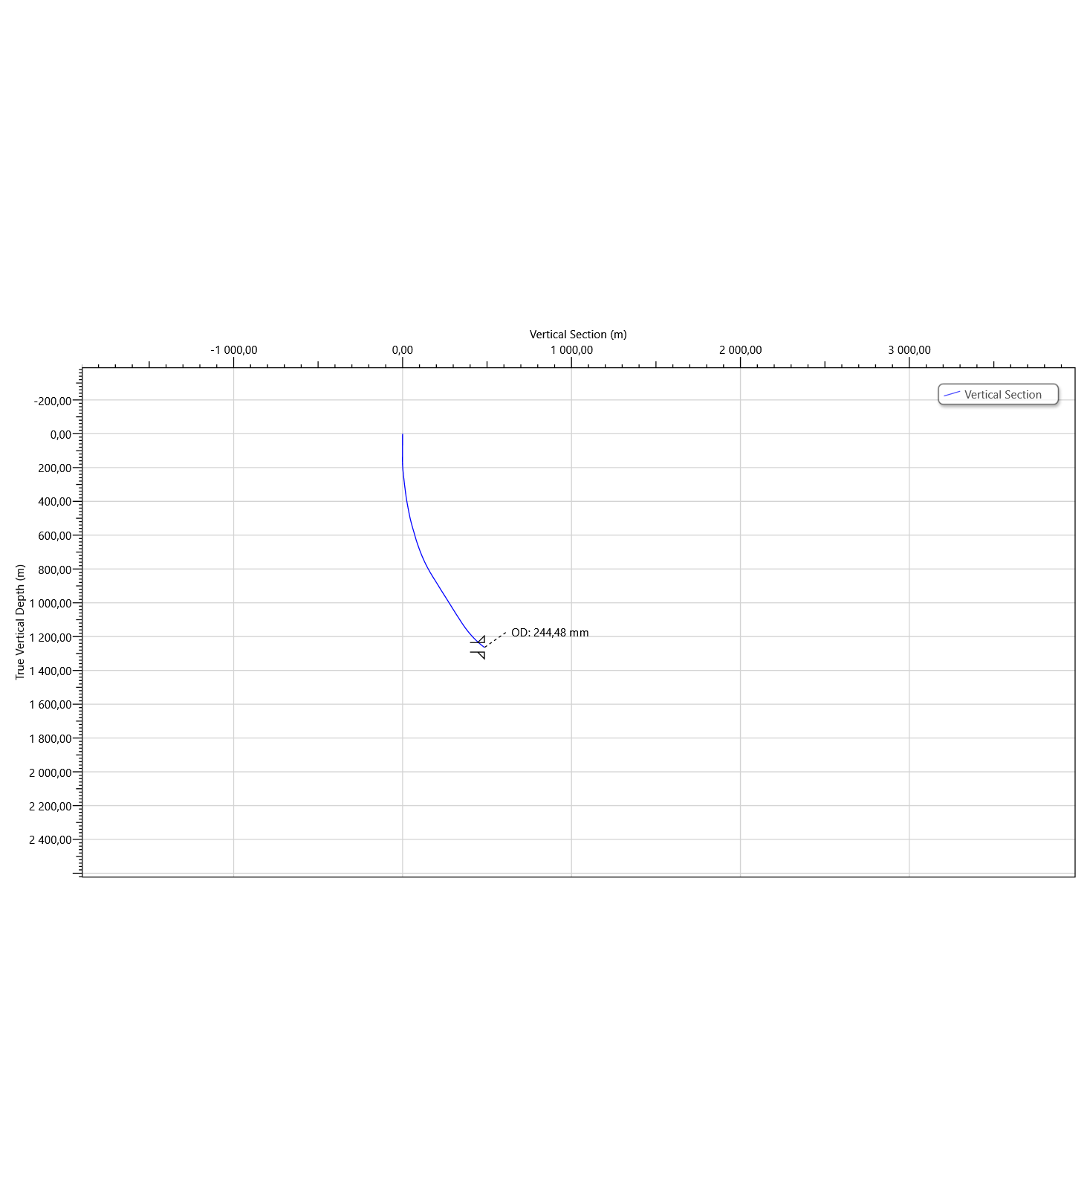
  - Plan View
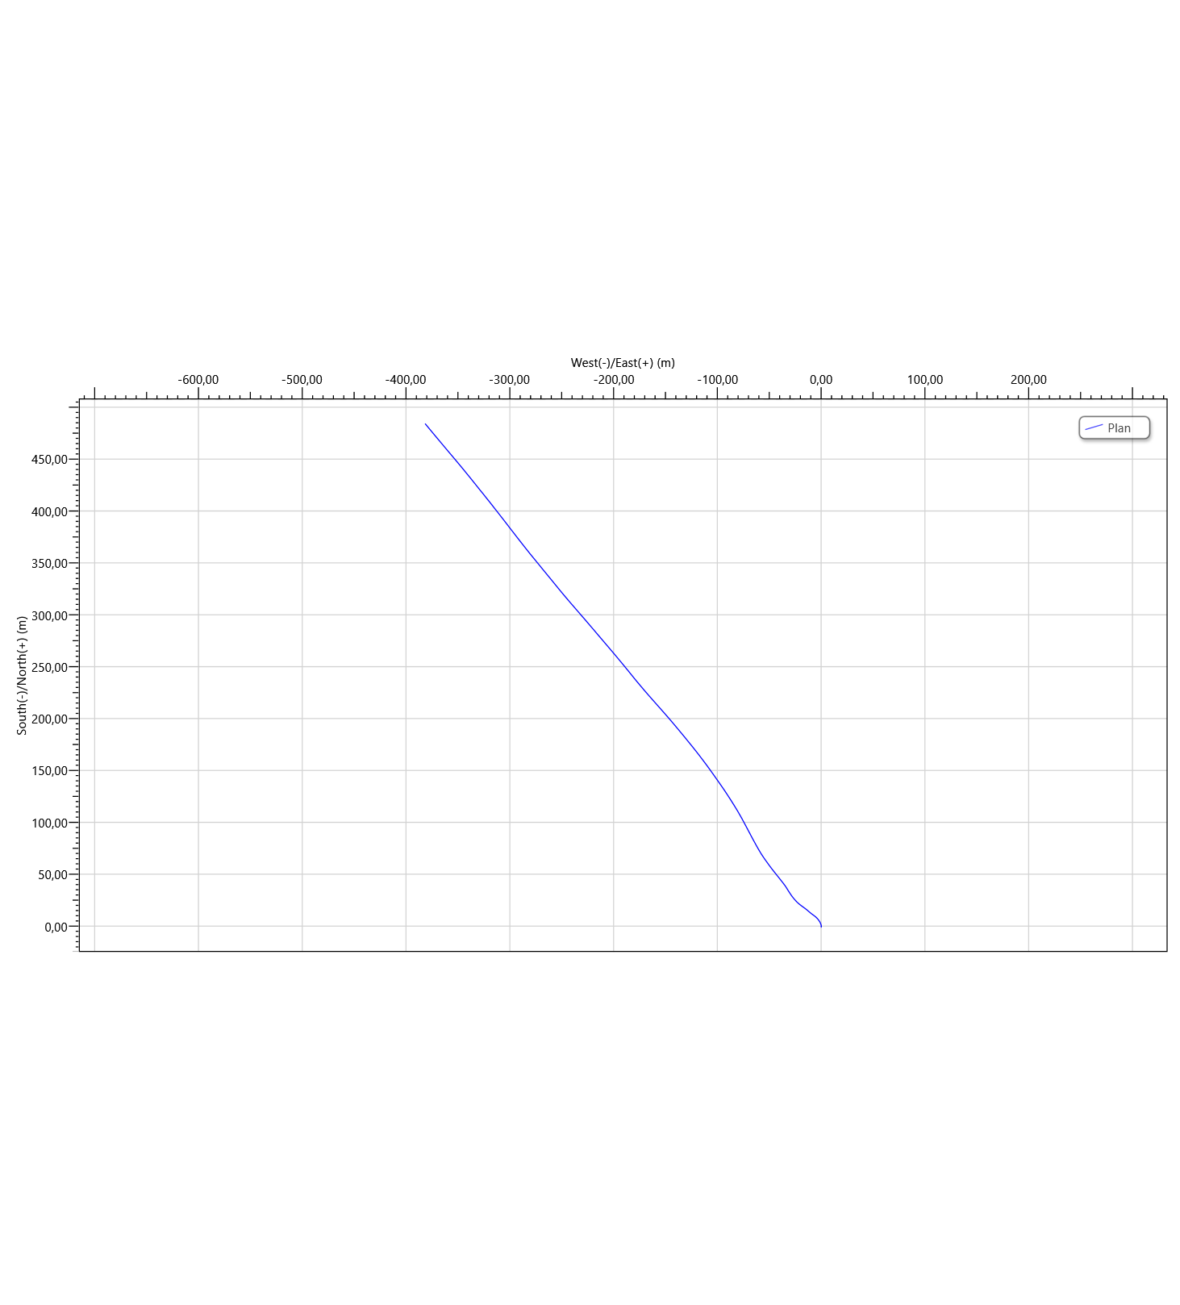

Torque & Drag Setup Data
  - Settings
Measured Depth of Bit | 1460,00 m | Bending Stress Magnification | No
Block Weight | 0,00 tonne | Stiff String Analysis | No
Enable Sheave Friction Correction | No | Viscous Torque and Drag | No
Pump Rate | 0,0000 m³/min | Contact Force Normalization Length | 9,45 m
Mechanical Efficiency (Single Sheave) | 97,00 | Lines Strung | 12
 |  | Side Force | N
Offset from Wellhead | m | Angle at Wellhead | °
  - Run Parameters
Start MD | 0,00 m | End MD | 1470,00 m
Step Size | 30,00 m
  - Normal Analysis Operational Parameters
Drilling | WOP/Overpull  (tonne) | Torque at Bit  (N-m)
Rotating On Bottom | NA | NA
Slide Drilling | NA | NA
Backreaming | NA | NA
Rotating Off Bottom
Tripping | Speed  (m/min) | RPM  (rpm)
Tripping In | 10,00 | 0
Tripping Out | 10,00 | 0
  - Friction Factors
Section Type | Coefficient of Friction
Casing | 0,23

  - String Fill Up
Use String Fill Up (Tripping In only) | No | Period | 0,00 m

Torque and Drag Results
  - Mechanical Limitations
Overpull Margin during a Tripping Out operation | 141,02 tonne | using | 100,00% of yield
Minimum Weight on Bit to Sinusoidal Buckle during a rotating on bottom operation | 18,14 tonne | at | 1202,85 m
Minimum Weight on Bit to Helical Buckle during a rotating on bottom operation | 24,05 tonne | at | 1202,85 m
Pick-Up Drag | 5,51 tonne
Slack-Off Drag | 4,39 tonne
Block Rating (Hoisting System) | tonne
Torque Rating (Rotating Equipment) | N-m
  - Load Summary
Load Condition | Stress Failure |  |  | Buckling Limits |  |  | Torque Failure | Torque at the Rotary Table  (N-m) | Total Windup with Bit Torque  (revs) | Total Windup without Bit Torque  (revs) | Measured Weight  (tonne) | Total Stretch  (m) | Axial Stress = 0 |  | Neutral Point Distance from surface  (m) | Neutral Point Distance from Bit  (m)
 | Fatigue | 90% Yield | 100% Yield | Sinusoidal | Helical | Lockup |  |  |  |  |  |  | Distance from Surface  (m) | Distance from Bit  (m)
Tripping In |  |  |  |  |  |  |  | 0,0 | 0,0 | 0,0 | 24,17 | 0,70 | 1211,32 | 248,68 | 1460,00 | 0,00
Tripping Out |  |  |  |  |  |  |  | 0,0 | 0,0 | 0,0 | 34,07 | 0,80 | 1289,18 | 170,82 | 1460,00 | 0,00

Torque and Drag Plots
  - Effective Tension
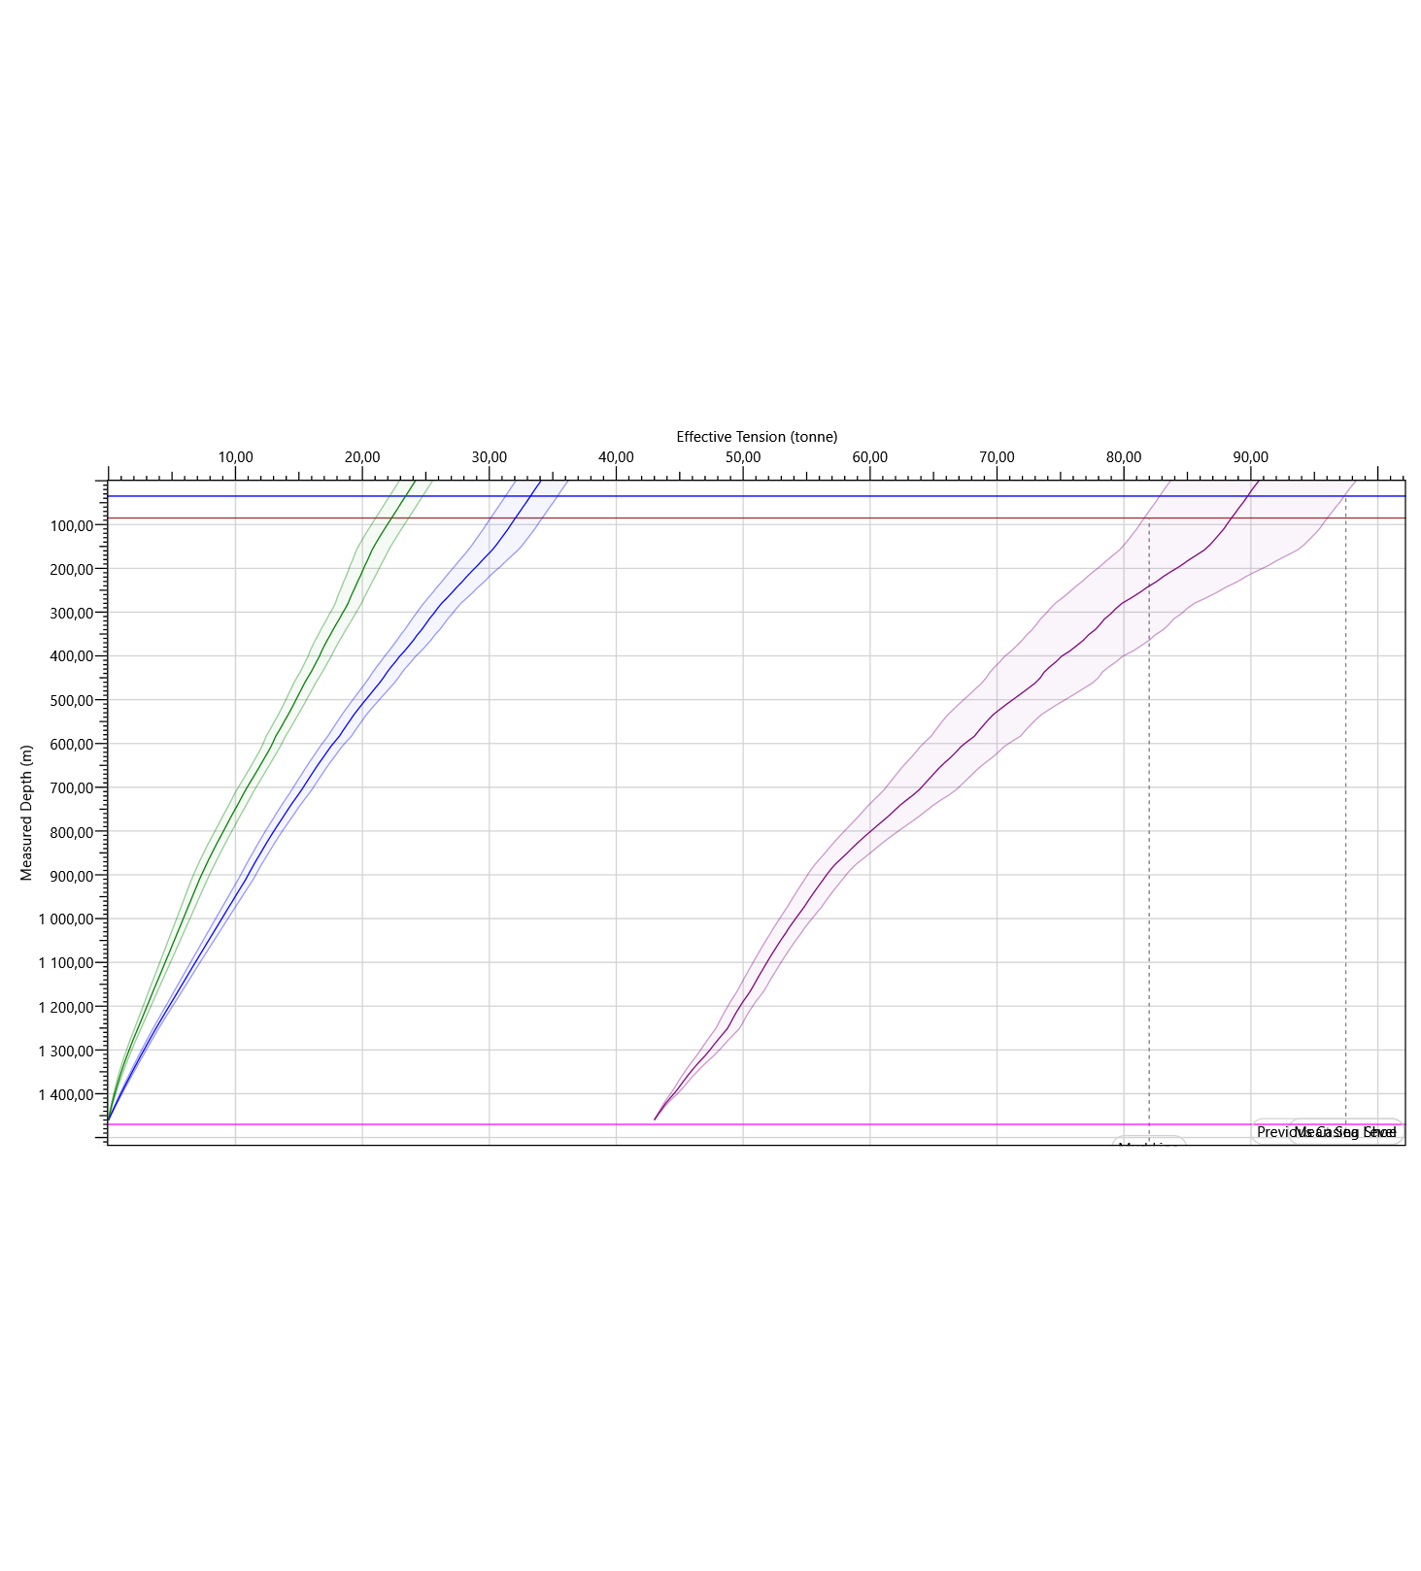
  - Hook Load
